**COMENIUS 2011 – 2012**

**2nd High School of Drapetsona**

**DRAMATIZING**

**4 COLONIAL PRODUCTS**

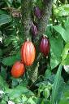 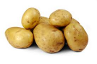  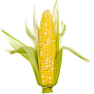

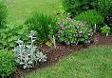

**Aytos 11 to 16 of February 2012 Dialogs and lyrics and music of the songs were produced by the students**

**Herbs and plants:** the students: Maria Stergiopoulou, Katerina Karampila, Dionysios Voulgarakis, Savvas Toulgeridis, Dimitrios Spatharis, Anna Saltouridou and the teachers: Christina Vottea, Evangelia Kafantari, Eleni Zervou, Effrosyni Chamilaki, Kleopatra Papacheimona

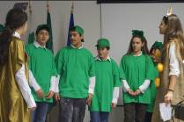 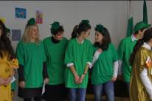

**Miss Cocoa**: MariaVentouri

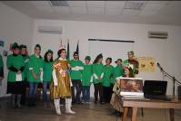

**Miss Potato:** Ariadni Balidi

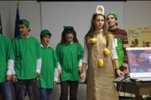

**Miss Sunflower:** KonstantinaKomninou

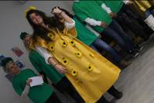

**Miss Corn:** Frederic Amanger (French teacher)

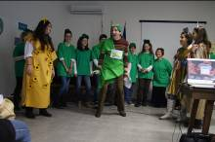

**Herbs and plants**: Once upon a time there were four little seeds. These little seeds wanted to become delicious and useful to the human kind, so  they sipped a lot of water and ate a lot of food and started growing and growing and the more they ate and drank, the more they grew. One day, the first cocoa plant, the first potato, the first sunflower and the first corn appeared. But as soon as they grew up, they started quarreling.

**Miss Cocoa**: (Song) I’m so happy and proud I’m the best, the sweetest, the prettiest! I’m Miss Cocoa!

**Miss Potato:** (song) You’re so humble, Miss Cocoa! Let me tell you now who ***I*** am! I’m Miss Potato! The most cosmopolitan, the most delicious of all. I’ve been traveling around the world since 1565………..

**Miss Cocoa** You may have traveled, dear Miss Potato, but I am the most popular! Everybody loves me. Nobody can resist me. I’m the food of gods, you know? I cure people! I have been cultivated for 2000 years on this Earth! My friend Ernan Cartel introduced me to Europe!

**Miss Potato:** I’m so impressed! Really! But I am present in all dishes! Just look around you! French fries, mashed potato, boiled potatoes, roast potatoes, Jacket potatoes, and baked potatoes! And, above all, potato crisps!!

**Miss Cocoa**: Stop glorifying yourself, little Miss Potato! I can be eaten as a chocolate and drunk as hot chocolate, and, if you pour me on the top of sweets, I can make sweets sweeter.

**Herbs and plants:** Here is Mr Sunflower, he’s been eavesdropping and now he’s here, ready to make you

reason with him.

**Miss Sunflower** (song) I’m really mad at you!

**Miss Cacao+ Miss Potato (together)**: Why?

**Miss Sunflower:** ‘Cause I’m delicious and healthy and I can cure people with my seeds, you know, Miss Cocoa? And I have traveled a lot more than you have, Miss Potato. And I have been cultivated for 3000 years!

**Herbs and plants:** All right, all right! Now stop bragging.

**Miss Corn: You’re right! Dear herbs and plants! Just look at them! Mr Sunflower is so vain! And Miss Potato and Miss Cocoa are so arrogant! But I am modest in my supreme nature. I am Miss Corn!**

**Herbs and Plants: Who?**

**Miss Corn: I’m Miss Corn! Like Corn flakes, the healthy food people have for breakfast every morning and like corn flour, that people use to make sweet pies! I’m like the grilled corn people are crunching on summer holiday afternoons… And, above all, remember I’m like pop corn! People eat buckets of pop corn as they watch films at the cinema and the TV.**

**Herbs and plants:** **(Ironically) Wow!! Really modest! (Change attitude) OK, OK, Miss Corn! All right! You’re great! All of you! But you are all growing from the Earth! In this you are like us, you come from faraway lands. But you are here now. We are all here, together, now. So let’s sing, dance and enjoy!**    

***SONGS***

***POTATO SONG***

Hello people, I’m the potato

come from Andes, that’s where I was born

one day he came there, he was foreigner

he took me later, and brought me to Europe

***CHOCOLATE SONG***

I was, a little chocolate you love me from

the moment that you ever tasted me

***Sunflower song***

The Inkas made me and you can taste

me, I used to be American but now I’m

International

***THE FINAL SONG – ALL TOGETHER***

We are friends

We are together

We are equal

AND

We are the same

We are different

We are special

In our way